IW-16
YEAR 9 SCIENCE
BIOLOGICAL SCIENCES
TEST - BODY SYSTEMS

NAME: CLASS: Mark: 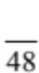

Multiple Choice Write the answer to each question in the appropriate box at right.
QUESTION | ANSWER
1
2
3
4
5
6
7
8
9
10
11
12
13
14
15
16
17
18
19
20
21
22
23

1. Which of the following lists contain only examples of mechanical
digestion?

(a) Chewing in the mouth and the churning by stomach muscles.
(b) Chewing in the mouth, protease break down of proteins.
(c) Churning by the stomach muscles and protease break down of
proteins.
(d) Protease break down of proteins is the only example.

2 . Where is the digested food absorbed into your blood?

(a) Mouth.
(b) Large intestine.
(c) Small intestine.
(d) Stomach.

3. What are the main functions of the stomach?

(a) To store food so that you can use it when you are hungry.
(b) To break food down into a thick soupy liquid and to begin protein digestion.
(c) To make enzymes to digest fats, proteins and carbohydrates.
(d) To digest all the food you eat so it can be absorbed in the small intestine.

4. The pancreas can be described as which of the following?

(a) An organ that produces enzymes.
(b) A site of chemical digestion.
(c) A site of mechanical digestion.
(d) An organ of excretion.

5. Absorption of water in the digestive system occurs in which of the following organs?

(a) The stomach.
(b) Large intestine.
(c) Liver.
(d) Anus.

6. When urine leaves the bladder it:

(a) is taken to the kidney.
(b) moves through the ureter.
(c) moves through the urethra.
(d) is taken to the liver.

7. What is the purpose of digesting your food?

(a) So that the muscles in your oesophagus can squeeze the pieces down to your stomach.
(b) So that you can break it into pieces small enough to swallow.
(c) To break it into molecules small enough to be absorbed into your blood.
(d) The food keeps your stomach and intestines alive by giving them energy.

8. How do the circulatory and excretory systems co-operate to keep you alive?

(a) The circulatory system, via the blood, delivers food to the kidneys, which then deliver wastes to the blood.
(b) The circulatory system, via the blood, delivers digested foods to the kidneys to keep them alive.
(c) The circulatory system, via the blood, delivers wastes to the kidneys, which then pass urine to the blood to be carried to the bladder.
(d) The circulatory system, via the blood, delivers wastes to the kidneys that they then excrete from the blood by forming urine.

9. A number of nutrients provide our bodies with energy. The main source of energy is:

(a) vitamins.
(b) protein.
(c) lipids.
(d) carbohydrates.

10. Two nutrient groups are required in minute (very small) amounts for healthy growth. They are:

(a) vitamins and carbohydrates.
(b) minerals and proteins.
(c) carbohydrates and proteins.
(d) vitamins and minerals.

11. Which of the following lists some functions of the blood?

(a) Transport of oxygen, food, wastes and heat.
(b) Carrying food, breathing, fighting infection and warming the body.
(c) Transporting oxygen and food, removing wastes and digesting food.
(d) Fighting infection, carrying food, breathing and digestion.

12. What do we call the heart chambers which pump blood out of the heart into the arteries?

(a) Left and right ventricles.
(b) Left ventricle and left atrium.
(c) Right atrium and right ventricle.
(d) Left atrium and right atrium.

13. According to the CSIRO's recommendations for healthy eating, people need to consume 3 serves a day of:
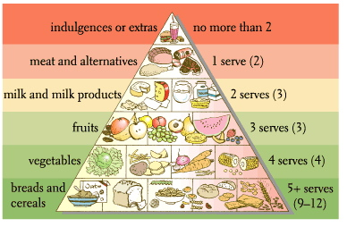

(a) meat and alternatives.
(b) bread and cereals.
(c) fruit.
(d) indulgences or extras.

14. What is the name of the group that includes the nutrients starch and sugar?

(a) Vitamins.
(b) Lipids.
(c) Fats.
(d) Carbohydrates.

15. The lungs are ventilated by muscular movements of the rib cage and the _____.

(a) trachea
(b) ribs
(c) alveoli
(d) diaphragm

16. _____ carry blood away from the heart.

(a) Arteries
(b) Bronchioles
(c) Veins
(d) Venules

17. The millions of tiny air sacs in your lungs are called _____.

(a) capillaries
(b) bronchioles
(c) alveoli
(d) bronchi

18. The lower end of the trachea divides into the left and right _____.

(a) oesophagus
(b) bronchi
(c) alveoli
(d) trachea

19. The smallest blood vessels in your body are called _____.

(a) capillaries
(b) venules
(c) arteries
(d) arterioles

20. In what part of the lung does actual gas exchange occur?

(a) The bronchiole.
(b) The trachea.
(c) The alveolus.
(d) The bronchus.

21. Backflow of blood back into the heart is prevented by _____, which allow blood to flow only one way.

(a) valves
(b) arteries
(c) atria
(d) veins

22. A cross-section of the small intestine shows that it is lined with tiny finger-like projections. What is the name of these projections?

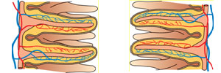

(a) Nephrons.
(b) Villi.
(c) Filaments.
(d) Capillaries.

23. The chamber of the heart which has the thickest wall is the _____.

(a) right atrium
(b) left atrium
(c) left ventricle
(d) right ventricle

Short Answer Write the answer to the questions in the spaces provided.

1. Write the name of the parts shown in the following diagramof the digestive system.
(6 marks)
PART | NAME
A
B
C
D
E
F
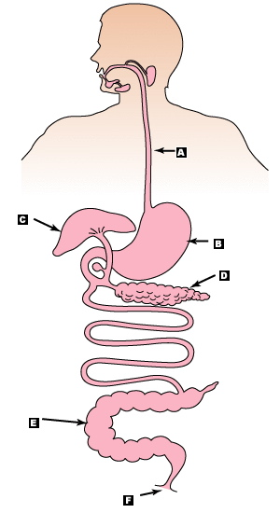

(3)

2. There are three enzymes that target the three major food groups. Complete the following table. (6 marks)

NAME OF ENZYME | TARGET FOOD GROUP

3. Label the parts of the heart marked A to F. (6 marks)
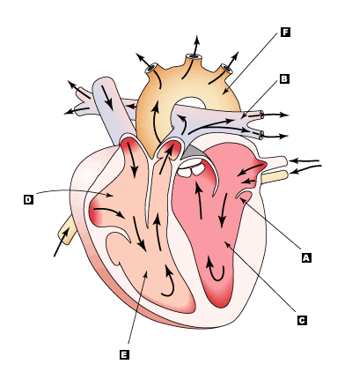

4. Use the following diagram of the human excretory system to help complete the table below. (4 marks)
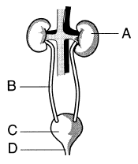
A
B
C
D
E
F
LETTER | NAME OF STRUCTURE
A
B
C
D

5. (a) Write a word equation for respiration. (1 mark)

(b) What are the waste products of respiration? (2 marks)

